NAME: |  | DATE:

PRACTICE EXERCISE # 1

- LE3_1.c

START
- INITIALIZE weeklyPay, WEEKS_IN_YEAR = 52
- PROMPT and READ userYearlypay
- CALCULATE weeklyPay = yearlyPay/ weeksInyear
- DISPLAY weeklyPay
END / STOP
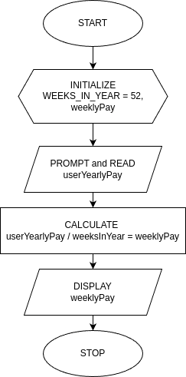

LE3_1.c

- LE3_2.c

START
1. INITIALIZE number, lastDigit, secondLastDigit, sum
2. PROMPT and READ number
3. CALCULATE lastDigit = number % 10
4. CALCULATE secondLastDigit = (number / 10) % 10
5. CALCULATE sum = lastDigit + secondLastDigit
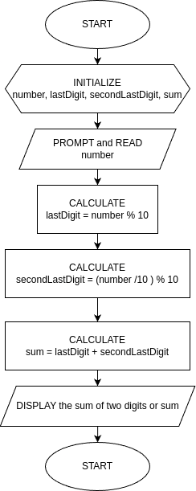
6. DISPLAY sum of the last digit
END / STOP

LE3_2 Flowchart

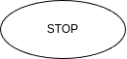

- LE3_3.c

START
1. INITIALIZE REGISTRATION_FEE = 450,
UNIT_FEE = 450,
PENALTY_FEE = 2260,
PENALTY_UNITS = 12

2. INITIALIZE firstSemUnits, secondSemUnits, firstSemTuition, secondSemTuition, totalTuition

3. PROMPT and READ “1st Semester Number of Units: “, firstSemUnits
4. PROMPT and READ “2nd Semester Number of Units: “, secondSemUnits

5. CALCULATE firstSemTuition = REGISTRATION_FEE + (firstSemUnits * UNIT_FEE),
5.1 firstSemPenalty = firstSemUnits / PENALTY_UNITS,
5.2 firstSemTuition += firstSemPenalty * PENALTY_FEE

6. CALCULATE secondSemTuiton = REGISTRATION_FEE + (secondSemUnits * UNIT_FEE),
secondSemPenalty = secondSemUnits / PENALTY_UNITS,
secondSemTuition += secondSemPenalty * PENALTY_FEE

7. CALCULATE totalTuition = firstSemTuition + secondSemTuition

8. DISPLAY "1st Semester Tuition Fee : ", (firstSemTuition, 2 decimal places)
9. DISPLAY "2nd Semester Tuition Fee : ", (secondSemTuition, 2 decimal places)
10. DISPLAY "Total Tuition Fee : ", (totalTuition, 2 decimal places)
END

LE3_3.c Flowchart
